Kickstarter – The Winners and Losers!

* Insights into categories which are consistently funded and those which are not!

February 13, 2019

Abdul Razak



|  |
| --- |
|  |
|  |
|  |

|  |
| --- |
| KickstarterCompany Vision     Study Details  Over two billion dollars have been raised using the massively successful crowdfunding service, Kickstarter, but not every project has found success. Of the over 300,000 projects launched on Kickstarter, only a third have made it through the funding process with a positive outcome.  Since getting funded on Kickstarter requires meeting or exceeding the project's initial goal, many organizations spend months looking through past projects in an attempt to discover some trick to finding success.  This project attempts to organize and analyze a database of four thousand past projects in order to uncover any hidden trends. |
| This project attempts to organize and analyze a database of four thousand past projects in order to uncover any trends |
| The Study Comprises of multiple countries and multiple categories. A summary is show below   |  |  | | --- | --- | | All country |  | |  |  | |  |  | | Categories | Grand Total | | film & video | 520 | | food | 200 | | games | 220 | | journalism | 24 | | music | 700 | | photography | 220 | | publishing | 237 | | technology | 600 | | theater | 1393 | | Grand Total | 4114 | |  |  |  1. What are three conclusions we can make about Kickstarter campaigns* given the provided data?     ***Conclusion 1:***  *The top three categories which were most successful in achieving their funding goals are*   * *Music,* * *Theater and Film & Video.*   *Theater had most number of successful projects, while Music had the highest percentage of successful campaigns.*  *\*the term ‘campaigns’ and ‘projects’ are used interchangeably.*    ***Conclusion 2****:*  *Data indicates certain sub-categories are consistently successful in achieving their goals, while there are other sub-categories which are consistent in failing to meet their goals.*    **Winning Sub-Categories**:  Rock, Documentary, Classical Music, Hardware, Electronic Music, Pop…..  **Losing Sub-Cat**:  Animation, Drama, Food Trucks, Jazz, Fiction, Faith, Video games….. |

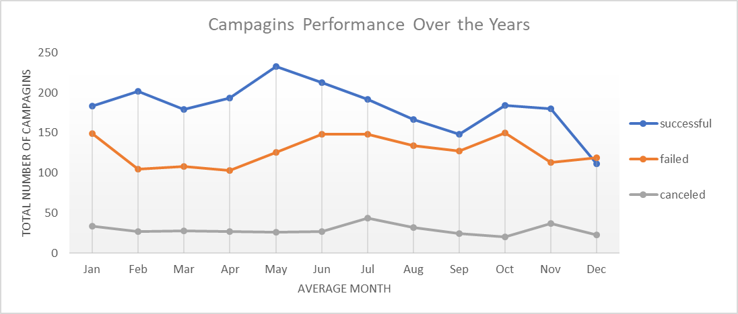

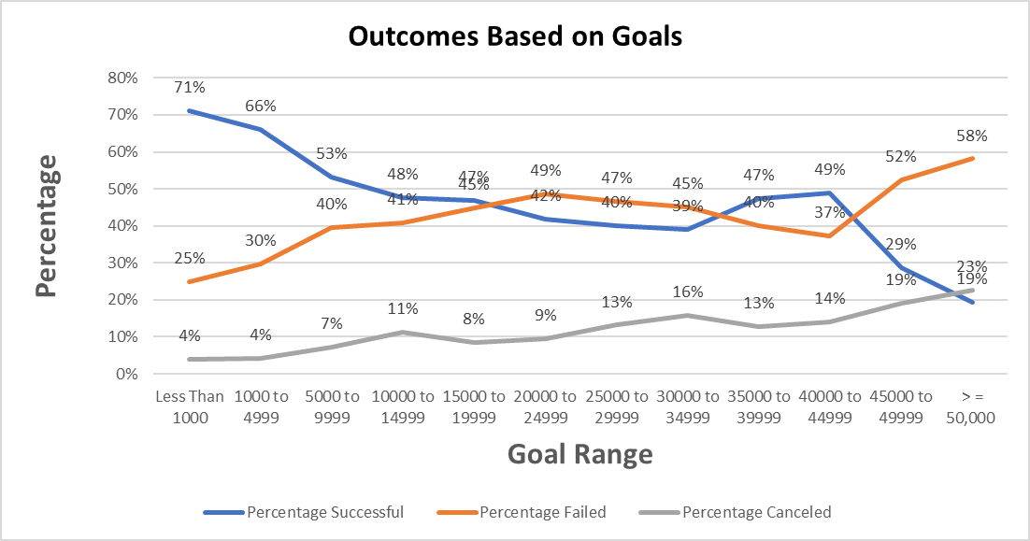

*Conclusion 3:*

*Best months to launch a campaign is April -May. Highest level of success is for campaigns which are below $5000 (66 to 71% success), while campaigns between $5,000 and $45,000 have about a half the chance to succeed (53 to 49%). Campaigns of 50,000 have 1 in 5 chance of success only. Failure rates and cancelation rates of campaigns gradually increase through the year increasing significantly during last months of the year.*

1. What are some of the limitations of this dataset?

Limitation of the data set include :

Size:

Size of the Data Set. Sample size is just over 4K while the actual campaigns processed were about 300K.

Quality:

We are not aware if all the categories and sub-categories were included in the data set. Missing some of them skews the data

We are assuming that external factors, influencing funding success will be consistent across the years, if this is not true, the data quality of data maybe impacted

Another limitation is that funding preferences may evolve and change based on the stakeholders and their view about categories.

1. What are some other possible tables/graphs that we could create?

We could create graphs across several elements using filters which would provide plenty of further insights.

* Example looking into the sub-categories across countries, and their success rates by years we can study if there are trends specific to countries.
* Other example would include, to further study what projects are canceled? Graphs using filters which show only sub-categories of campaigns which were canceled across the years across individual countries, will allows the opportunity to get better understanding of challenges by country by sub-cat.
* Similarly study of drilling deeper into what projects/campaigns are failing across the sub-category, location (country), years/month) will provide insight into trends
* We could do a regression analysis to find the relationships between funding success and categories